-20IT928 PROJECT WORK

# RETAIL STOCK STORE INVENTORY ANALYSIS

**A PROJECT REPORT**

***Submitted by***

|  |  |
| --- | --- |
| **ROHAN JAI D** | **(111720102126)** |
| **RAKESH S D** | **(111720102122)** |
| **SANDHEEP KRISHNA A** | **(111720102137)** |
| **SANJAY C** | **(111720102138)** |
| **PAVAN KOUSHIK S** | **(111720102312)** |

***in partial fulfillment for the award of the degree of***

# BACHELOR OF ENGINEERING

## IN

**DEPARTMENT OF COMPUTER SCIENCE AND ENGINEERING**

# R.M.K. ENGINEERING COLLEGE

(An Autonomous Institution)

**R.S.M. Nagar, Kavaraipettai-601 206**

# ANNA UNIVERSITY: CHENNAI 600 025

## MARCH 2021

R.M.K. ENGINEERING COLLEGE (An Autonomous Institution)

**R.S.M. Nagar, Kavaraipettai-601 206**

# BONAFIDE CERTIFICATE

Certified that this project report **“RETAIL STOCK STORE INVENTORY ANALYSIS”** is the bonafide work of **ROHAN JAI D (111720102126), RAKESH S D (111720102122), SANDHEEP KRISHNA A (111720102137), SANJAY C (111720102138), PAVAN KOUSHIK S (111720102312)** who carried out the project under my supervision**.**

## SIGNATURE SIGNATURE

**Dr. T. Sethukarasi, M.E., Ph.D., Dr. C. Geetha, M.E., Ph.D.,**

## Professor and Head Supervisor

Associate Professor

Computer Science and Engineering Computer Science and Engineering,

R.M.K. Engineering College R.M.K. Engineering College,

R.S.M. Nagar, Kavaraipettai, R.S.M. Nagar, Kavaraipettai, Tiruvallur District – 601206. Tiruvallur District – 601206.

Submitted for the Project Viva - Voce held on ……………. at **R.M.K. Engineering College**, Kavaraipettai, Tiruvallur District – 601 206.

# ACKNOWLEDGEMENT

We earnestly portray our sincere gratitude and regard to our beloved **Chairman Shri. R. S. Munirathinam, our Vice Chairman, Mr. R. M. Kishore** and **our Director, Shri. R. Jyothi Naidu,** for the interest and affection shown towards us throughout the course.

We convey our sincere thanks to our **Principal**, **Dr. K. A. Mohamed Junaid,**

for being the source of inspiration in this college.

We reveal our sincere thanks to our **Professor** and **Head of the Department**, Computer Science and Engineering**, Dr. T. Sethukarasi,** for her commendable support and encouragement for the completion of our project.

We would like to express our sincere gratitude for our mini project coordinator **Dr. C. Geetha, Associate Professor, Dr. Sandra Johnson, Professor and Ms. Anusha Sanampudi, Assistant Professor** for their valuable suggestions towards the successful completion for this project in a global manner.

We take this opportunity to extend our thanks to all faculties of Department of Computer Science and Engineering, parents and friends for all that they meant to us during the crucial times of the completion of our project.

**TABLE OF CONTENTS**

|  |  |  |
| --- | --- | --- |
| **CHAPTER** | **TITLE** | **PAGE NO** |
|  | **ABSTRACT** | 5 |
|  | **LIST OF FIGURES** | 6 |
|  | **LIST OF ABBREVATIONS** | 7 |
| **1** | **INTRODUCTION** |  |
|  | 1.1 Problem Statement | 8 |
|  | 1.2 Project Scope and Objectives | 8 |
| **2** | **OVERALL DESCRIPTION** |  |
|  | 2.1 Project Specification | 9 |
|  | 2.2 Use Case Diagrams | 10 |
|  | 2.3 Class Diagrams / ER Diagrams | 11 |
|  | 2.4 System Architecture | 12 |
| **3** | **EXTERNAL INTERFACE REQUIREMENTS** |  |
|  | 3.1 User Interfaces | 13 |
|  | 3.2 Hardware Interfaces | 13 |
|  | 3.3 Software Interfaces | 13 |
| **4** | **TESTING** |  |
|  | 4.1 Test Plan | 14 |
|  | 4.2 Test Procedure | 14 |
|  | 4.3 Test Cases | 15 |
| **5** | **FUTURE ENHAANCEMENTS** | 16 |
| **6** | **CONCLUSION** | 17 |
|  | **SCREENSHOTS** | 18 |

**ABSTRACT**

* Efficient inventory management is pivotal in modern retail. This project focuses on retail store stock inventory analysis, exploring strategies to optimize operations and decision-making. It covers demand forecasting, inventory turnover, classification methods, economic order quantity, safety stock, supplier performance, replenishment strategies, and technology integration. By melding operational research, supply chain practices, and retail expertise, this study unveils the intricate relationship between inventory, demand patterns, and the supply chain. Through data analysis and advanced tools, it provides insights into optimal stock levels, risk reduction, cost savings, and consistent product availability. The project aligns with retail's competitiveness and sustainability goals, guiding proactive inventory management for better customer satisfaction and financial health.

## LIST OF FIGURES

FIG.NO FIGURE NAME PAGE NUMBER

1. Use case diagram 10
2. Class diagram 11
3. ER diagram 11
4. System Architecture 12

## LIST OF ABBREVIATIONS

S.NO ABBREVIATION EXPANSION

1. OS Operating System
2. HTML Hyper Text Markup Language
3. DB Data Base
4. E-R Entity Relationship diagram
5. CSS Cascading Style Sheets

## CHAPTER 1 INTRODUCTION

### Problem Statement:

Due to poor inventory retailers are not able to provide right goods to consumer in right quantity at right place in right time. Through analysis and visualization of stock data user can meet customer demand without running out of stock or carrying excess supply.

### Project Scope and Objective:

* + 1. Scope of the Project:

This scope outlines the key aspects of the project, including its objectives, deliverables, execution, stakeholders, constraints, benefits, timeline, risks, and a brief conclusion. It provides a clear overview of the project's purpose and expected outcomes.

### Objective of the Project:

Our main objective is to analyze historical sales data to predict demand patterns, implement inventory turnover strategies for efficient stock management, evaluate safety stock levels to prevent stockouts, assess supplier performance and lead times, analyze stock aging to reduce waste and obsolescence.

## CHAPTER 2 OVERALL DESCRIPTION

### Project Specification:

Our project is a Stock Inventory Analysis System and it contains all the information about stock value of the products. We named our website as “Retail Stock Inventory Analysis System”.

There are three sections in our website, they are

* + - HOME
    - UPLOAD AND ANALYZE
    - VIEW OUTLIERS

Initially when you login into our website, you will get the home page which contains the above mentioned three section. You can come back to the home page from any other page of the website.

The second section is Upload and Analyze section which contains the analysis of dataset by various methods such as Linear Regression, Random Forest Regressor, Gradient Boosting, KNN. The third section is View Outliers section in which we detect and analyze the outliers present in the dataset.

### USE CASE DIAGRAM

This use case diagram describes the interaction between the user and the website.

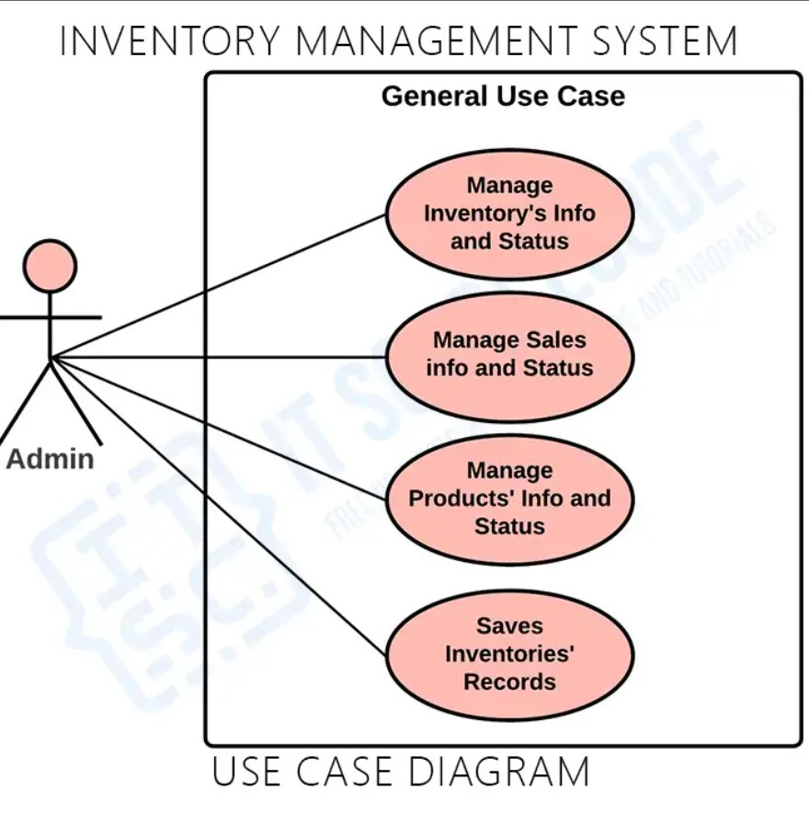

Figure 1: Use case diagram

### CLASS DIAGRAM

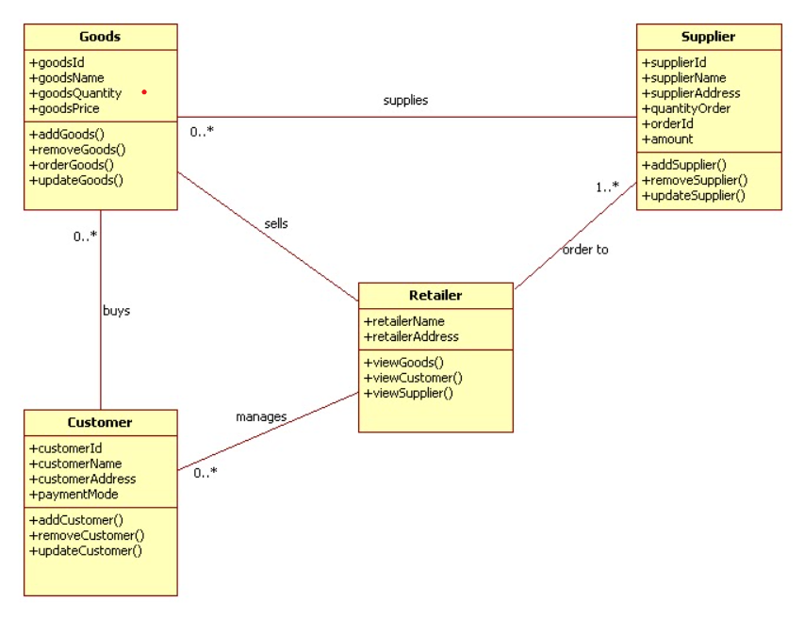

Figure 2: Class Diagram

### E-R DIAGRAM:

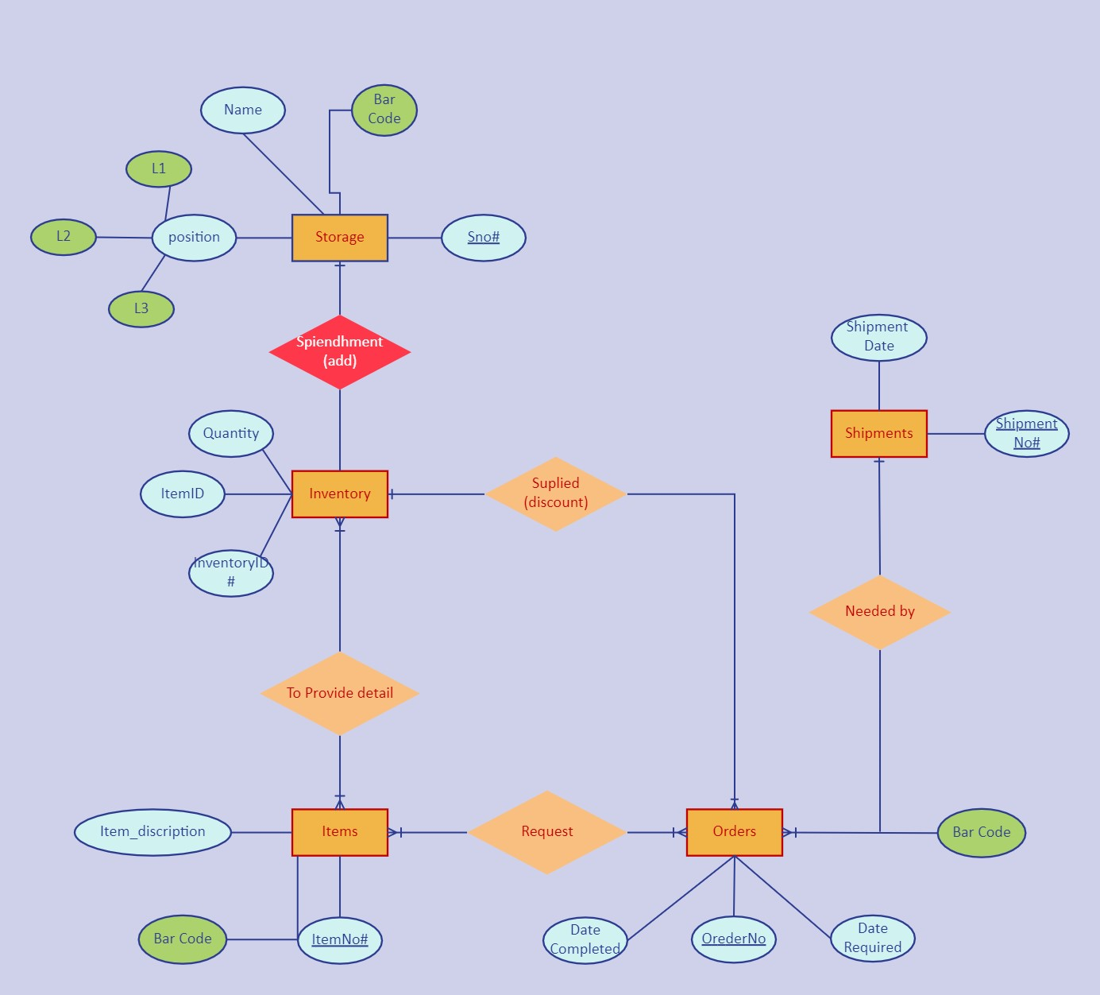

Figure 3: ER Diagram

### SYSTEM ARCHITECTURE:

The architecture diagram defines the fundamental structures of a software system and the discipline of creating such structures and the structured solution of the proposed idea.

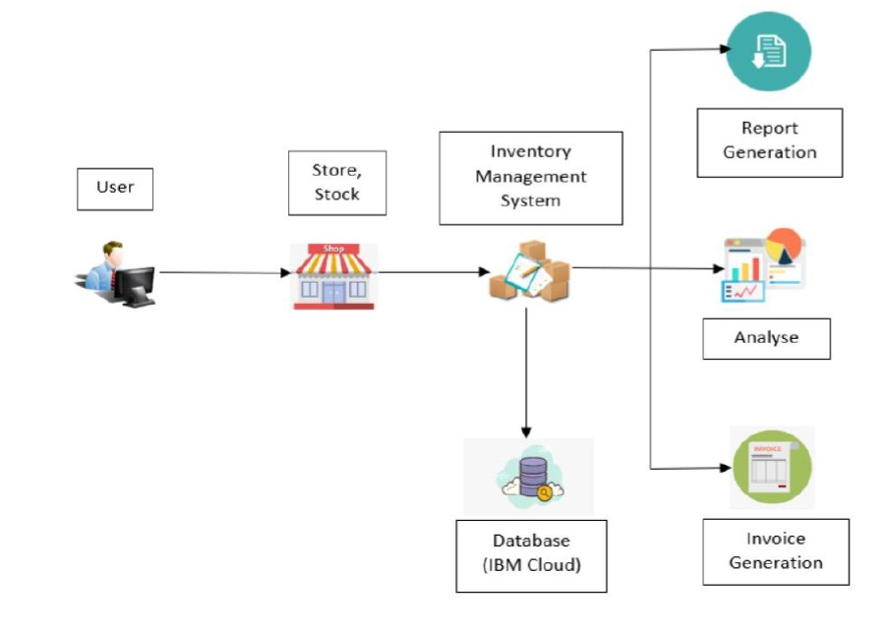

### Figure 4: Architecture Diagram

* + - The frontend technology used is Streamlit.
    - The backend used to build the application is Python.

## CHAPTER 3

EXTERNAL INTERFACE REQUIREMENTS

### USER INTERFACE:

Any popular OS that will allow the use of a browser to view and access web pages. In order to make the user comfortable, we have displayed all the main details in our home page itself.

### HARDWARE INTERFACE:

Any kind of internet connection like WIFI, modem data etcetera, to allow the browser interfaces to connect to the website. The website can be accessed through any devices like mobile, computer, laptop, tablet, etc.

### SOFTWARE INTERFACE:

Some of the software interfaces which you can use to access our website are

* + - Opera
    - Google chrome
    - Mozilla Firefox
    - Apple Safari

## CHAPTER 4 TESTING

### TEST PLAN:

Scope - The scope of the testing is to make the user to go through all the web pages easily.

Test Deliverables – To ensure a seamless and efficient retail experience, ultimately benefiting both the retail store and its valued customers.

### TEST PROCEDURE:

The test plan is shown below

|  |  |
| --- | --- |
| Name of the test | Things to be tested |
| API testing | User’s comfort with website should be tested. |
| Unit testing | Every page of the website should be tested. |
| Integration testing | Connection between the webpages are tested. |
| System testing | The functional flow of the webpages are tested. |

* 1. TEST CASES:

|  |  |  |  |  |
| --- | --- | --- | --- | --- |
| TEST CSE ID | TEST NAME | EXPECTED RESULTS | ACTUA RESULTS | STATUS |
| 1. | While opening  , the site should open | Site should open | As expected | Pass |
| 2. | On pressing browse file button | Buttons should navigate. | As expected | Pass |
| 3. | Testing the Linear regression model | Model should  work | As expected | Pass |
| 4. | Testing the Random Forest Regressor model | Model should work | As expected | Pass |
| 5. | Testing the Gradient boost model | Model should work | As expected | Pass |

## CHAPTER 5 FUTURE ENHANCEMENT

* + - Develop Mobile apps for inventory management.
    - Explore blockchain technology to enhance supply chain transparency
    - Implement intelligent replenishment systems that automatically trigger orders or restocking requests when inventory levels reach pre-defined thresholds, reducing the need for manual intervention.

## CHAPTER 6 CONCLUSION

In conclusion, the enhancements made in this project will prove to be invaluable, benefiting not only the retail store and its staff but also enhancing the experience for customers and stakeholders alike. These improvements in inventory management and operational efficiency will contribute to a more streamlined and customer-centric retail environment.

## SCREENSHOTS

